Ex 9 :
ListofPlayers.js
import React from 'react';

const ListofPlayers = () => {
const players = [
{ name: 'Rohit', score: 85 },
{ name: 'Gill', score: 45 },
{ name: 'Kohli', score: 95 },
{ name: 'Rahul', score: 30 },
{ name: 'Iyer', score: 77 },
{ name: 'Pandya', score: 60 },
{ name: 'Jadeja', score: 35 },
{ name: 'Ashwin', score: 68 },
{ name: 'Bumrah', score: 90 },
{ name: 'Shami', score: 40 },
{ name: 'Kuldeep', score: 50 }
];

const below70 = players.filter(player => player.score < 70); // Arrow function

return (
<div>
<h2>All Players</h2>
{players.map((player, index) => (
<p key={index}>{player.name} - {player.score}</p>
))}

<h3>Players with Score Below 70</h3>
{below70.map((player, index) => (
<p key={index}>{player.name} - {player.score}</p>
))}
</div>
);
};

export default ListofPlayers;
IndianPlayers.js
import React from 'react';

const IndianPlayers = () => {
const teamPlayers = ["Player1", "Player2", "Player3", "Player4", "Player5", "Player6"];

// Destructuring the array
const [odd1, even1, odd2, even2, odd3, even3] = teamPlayers;

const T20players = ['Rohit', 'Kohli', 'Bumrah'];
const RanjiPlayers = ['Jaiswal', 'Sarfaraz', 'Unadkat'];

// Merging using spread operator
const allPlayers = [...T20players, ...RanjiPlayers];

return (
<div>
<h2>Odd Team Players</h2>
<ul>
<li>{odd1}</li>
<li>{odd2}</li>
<li>{odd3}</li>
</ul>

<h2>Even Team Players</h2>
<ul>
<li>{even1}</li>
<li>{even2}</li>
<li>{even3}</li>
</ul>

<h2>Merged T20 + Ranji Players</h2>
<ul>
{allPlayers.map((player, index) => <li key={index}>{player}</li>)}
</ul>
</div>
);
};

export default IndianPlayers;
App.js
import React from 'react';
import './App.css';
import ListofPlayers from './components/ListofPlayers';
import IndianPlayers from './components/IndianPlayers';

function App() {
const flag = false;
// Set to false to show IndianPlayers component instead

return (
<div className="App">
<h1>🏏 Cricket App</h1>
{flag ? <ListofPlayers /> : <IndianPlayers />}
</div>
);
}

export default App;
App.js
import React from 'react';
import './App.css';
import ListofPlayers from './components/ListofPlayers';
import IndianPlayers from './components/IndianPlayers';

function App() {
const flag = true;
// Set to false to show IndianPlayers component instead

return (
<div className="App">
<h1>🏏 Cricket App</h1>
{flag ? <ListofPlayers /> : <IndianPlayers />}
</div>
);
}

export default App;

Output :
Flag = true
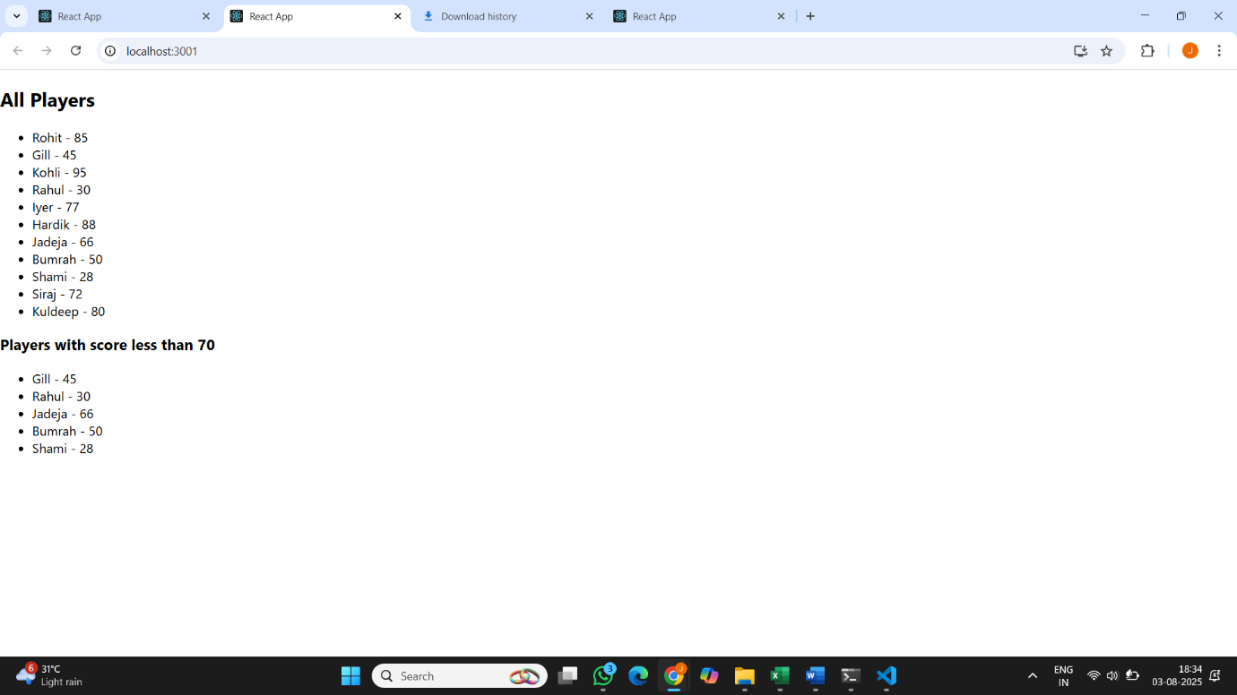
Flag = false
